CLIMATE CHANGE

GLOBAL WARMING –

**Global warming** is the rise in the average temperature of Earth's atmosphere and oceans since the late 19th century and its projected continuation. Since the early 20th century, Earth's mean surface temperature has increased by about 0.8 °C (1.4 °F), with about two-thirds of the increase occurring since 1980.[[2]](http://en.wikipedia.org/wiki/Global_Warming#cite_note-AmericasClimateChoices-2011-FullReport-2) Warming of the [climate system](http://en.wikipedia.org/wiki/Climate_system) is unequivocal, and scientists are more than 90% certain that it is primarily caused by increasing concentrations of [greenhouse gases](http://en.wikipedia.org/wiki/Greenhouse_gas) produced by human activities such as the burning of [fossil fuels](http://en.wikipedia.org/wiki/Fossil_fuel) and [deforestation](http://en.wikipedia.org/wiki/Deforestation).

The following visualization shows the change in temperature since 1880 **– (avg_temp_anomaly.html)**

Greenhouse Effect –

The greenhouse effect is the process by which [absorption](http://en.wikipedia.org/wiki/Absorption_(electromagnetic_radiation)) and [emission](http://en.wikipedia.org/wiki/Emission_spectrum) of [infrared](http://en.wikipedia.org/wiki/Infrared) radiation by gases in the [atmosphere](http://en.wikipedia.org/wiki/Atmosphere) warm a [planet](http://en.wikipedia.org/wiki/Planet)'s lower atmosphere and surface. Naturally occurring amounts of greenhouse gases have a mean warming effect of about 33 °C (59 °F).[[54]](http://en.wikipedia.org/wiki/Global_Warming#cite_note-IPCC_WG1_AR4_Ch1-54)[[C]](http://en.wikipedia.org/wiki/Global_Warming#cnote_C) The major greenhouse gases are [water vapor](http://en.wikipedia.org/wiki/Water_vapor), which causes about 36–70% of the greenhouse effect; [carbon dioxide](http://en.wikipedia.org/wiki/Carbon_dioxide) (CO2), which causes 9–26%; [methane](http://en.wikipedia.org/wiki/Methane) (CH4), which causes 4–9%; and [ozone](http://en.wikipedia.org/wiki/Ozone) (O3), which causes 3–7%.[[55]](http://en.wikipedia.org/wiki/Global_Warming#cite_note-55)[[56]](http://en.wikipedia.org/wiki/Global_Warming#cite_note-56)[[57]](http://en.wikipedia.org/wiki/Global_Warming#cite_note-57) Clouds also affect the radiation balance through [cloud forcings](http://en.wikipedia.org/wiki/Cloud_forcing) similar to greenhouse gases.

The following figure shows the flows of [energy](http://commons.wikimedia.org/wiki/Energy) between [space](http://commons.wikimedia.org/wiki/Space), the [atmosphere](http://en.wikipedia.org/wiki/Earth%27s_atmosphere), and the Earth's surface, and shows how these flows combine to trap heat near the surface and create the [greenhouse effect](http://en.wikipedia.org/wiki/greenhouse_effect). Energy exchanges are expressed in [watts](http://en.wikipedia.org/wiki/watt) per square [meter](http://en.wikipedia.org/wiki/meter) (W/m2)

[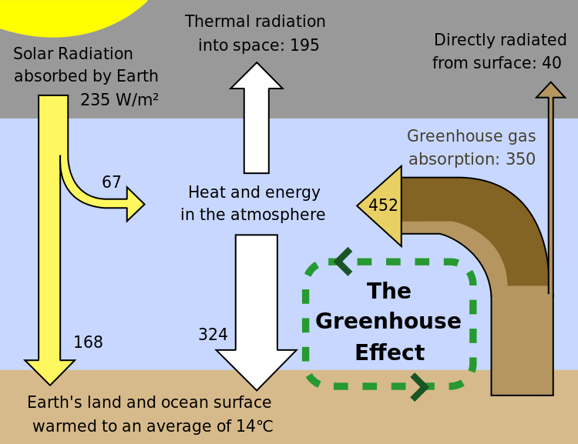](http://upload.wikimedia.org/wikipedia/commons/5/58/Greenhouse_Effect.svg)

Human activity since the [Industrial Revolution](http://en.wikipedia.org/wiki/Industrial_Revolution) has increased the amount of greenhouse gases in the atmosphere, leading to increased radiative forcing from CO2, methane, tropospheric ozone, [CFCs](http://en.wikipedia.org/wiki/Chlorofluorocarbon) and [nitrous oxide](http://en.wikipedia.org/wiki/Nitrous_oxide). The [concentrations](http://en.wikipedia.org/wiki/Greenhouse_gas#Anthropogenic_greenhouse_gases) of CO2 and methane have increased by 36% and 148% respectively since 1750. The [concentrations](http://en.wikipedia.org/wiki/Greenhouse_gas#Anthropogenic_greenhouse_gases) of various greenhouse gasses are shown **(conc of various gases.html)**

CO2 is the major greenhouse gas whose concentration has increased mainly due to human factors. Here is a map displaying major countries and their CO2 emissions. **(CO2.html)**

The major emitters of CO2 are shown in the following Bubble Diagram **(co2_bubble.html)**

SOURCES OF GREENHOUSE GASES –

Water vapor is available in the atmosphere and contributes to about 50% of the total greenhouse effect. Over the last three decades of the 20th century, gross domestic product per capita and [population growth](http://en.wikipedia.org/wiki/Population_growth) were the main drivers of increases in greenhouse gas emissions.[[65]](http://en.wikipedia.org/wiki/Global_Warming#cite_note-65) CO2 emissions are continuing to rise due to the burning of fossil fuels and land-use change.

The burning of [fossil fuels](http://en.wikipedia.org/wiki/Fossil_fuels) has contributed to a 40% increase in the concentration of [carbon dioxide in the atmosphere](http://en.wikipedia.org/wiki/Carbon_dioxide_in_Earth%27s_atmosphere) from 280 ppm to 397 ppm, despite the uptake of a large portion of the emissions by various natural "sinks" involved in the [carbon cycle](http://en.wikipedia.org/wiki/Carbon_cycle).[[5]](http://en.wikipedia.org/wiki/Greenhouse_gas#cite_note-cdiac-5)[[6]](http://en.wikipedia.org/wiki/Greenhouse_gas#cite_note-6) Anthropogenic carbon dioxide (CO2) emissions (i.e., emissions produced by human activities) come from [combustion](http://en.wikipedia.org/wiki/Combustion) of [carbon based fuels](http://en.wikipedia.org/wiki/Carbon_based_fuel), principally [wood](http://en.wikipedia.org/wiki/Wood), [coal](http://en.wikipedia.org/wiki/Coal), [oil](http://en.wikipedia.org/wiki/Oil), and [natural gas](http://en.wikipedia.org/wiki/Natural_gas).[[7]](http://en.wikipedia.org/wiki/Greenhouse_gas#cite_note-7)

Here is a pie chart depicting the various human activities that lead to the emissions of these gases – **(Sources_of_gases.html)**

Effects of Global Warming –

Global warming has been detected in a number of natural systems. Some of these changes are described in the section on [observed temperature changes](http://en.wikipedia.org/wiki/Global_warming#Observed_temperature_changes), e.g., [sea level rise](http://en.wikipedia.org/wiki/Current_sea_level_rise) and widespread decreases in [snow](http://en.wikipedia.org/wiki/Snow) and [ice](http://en.wikipedia.org/wiki/Ice) extent.[[120]](http://en.wikipedia.org/wiki/Global_Warming#cite_note-ipcc.ch-120) Most of the increase in global average temperature since the mid-20th century is, with high probability,[[D]](http://en.wikipedia.org/wiki/Global_Warming#cnote_D) attributable to human-induced changes in greenhouse gas concentrations.

Changes in regional climate are expected to include greater warming over land, with most warming at high northern [latitudes](http://en.wikipedia.org/wiki/Latitudes), and least warming over the [Southern Ocean](http://en.wikipedia.org/wiki/Southern_Ocean) and parts of the North Atlantic Ocean.[[122]](http://en.wikipedia.org/wiki/Global_Warming#cite_note-IPCC_AR4_SYR_2007-122) Snow cover area and sea ice extent are expected to decrease, with the Arctic expected to be largely ice-free in September by 2037.

It is calculated that, with [high statistical confidence](http://en.wikipedia.org/wiki/Confidence_interval), certain weather events, such as the heat waves in [Texas](http://en.wikipedia.org/wiki/Texas) and the [2003 European heat wave](http://en.wikipedia.org/wiki/2003_European_heat_wave), would not have occurred without global warming. Extremely hot outliers, defined as three [standard deviations](http://en.wikipedia.org/wiki/Standard_deviation) from climatology records, now cover about 10% of the land surface and, under present trends, would be the norm by 2050. These temperatures are expected to exacerbate the hydrological cycle, with more intense [droughts](http://en.wikipedia.org/wiki/Drought) and [floods](http://en.wikipedia.org/wiki/Flood).[[126]](http://en.wikipedia.org/wiki/Global_Warming#cite_note-126) The effect on hurricane activity is less certain.

In terrestrial [ecosystems](http://en.wikipedia.org/wiki/Ecosystem), the earlier timing of spring events, and poleward and upward shifts in plant and animal ranges, have been linked with high confidence to recent warming.[[120]](http://en.wikipedia.org/wiki/Global_Warming#cite_note-ipcc.ch-120) Future climate change is expected to particularly affect certain ecosystems, including [tundra](http://en.wikipedia.org/wiki/Tundra), [mangroves](http://en.wikipedia.org/wiki/Mangrove), and [coral reefs](http://en.wikipedia.org/wiki/Coral_reef).[[122]](http://en.wikipedia.org/wiki/Global_Warming#cite_note-IPCC_AR4_SYR_2007-122) It is expected that most ecosystems will be affected by higher atmospheric CO2 levels, combined with higher global temperatures.[[128]](http://en.wikipedia.org/wiki/Global_Warming#cite_note-128) Overall, it is expected that climate change will result in the [extinction](http://en.wikipedia.org/wiki/Extinction) of many species and reduced diversity of ecosystems.